**HOW TO ORDER LUNCHES THROUGH FLEXISCHOOL**

1. Open up FlexiSchool and login (or register for the first time) It will take you straight to this page, then select Order Food

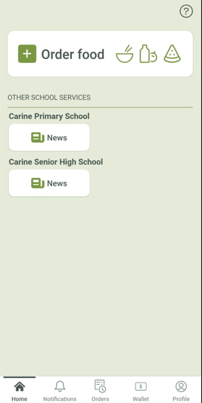



1. Select the child you want to order for, then you need to select the Carine PS section

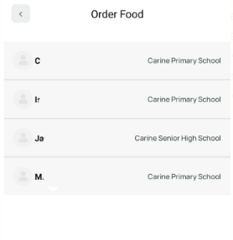



1. You may see this page to choose a date for your order

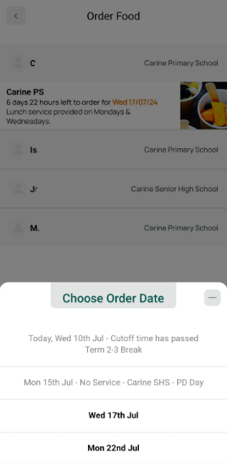



1. Once selected date, the New Order screen comes up and you can either select your Fast Order and just hit the Add Items button or SKIP and do a new fresh order.

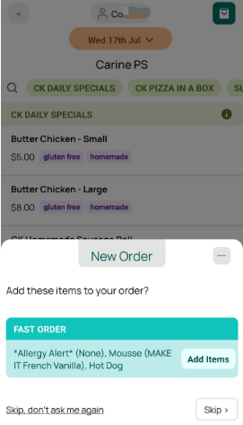



1. With all new fresh orders, you will then need to select for the *Allergy Alert* and hit Add Item button at the bottom of the page.

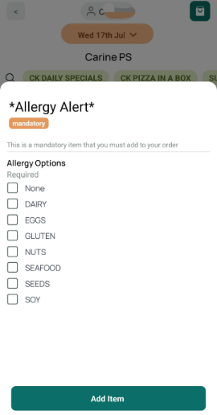



1. Then you can scroll through the list of available items (if something is not available it will be greyed out), once you have selected and item, it may come up with another page if they have options under that, ie: Select a drink, then another page will come up with flavours. Once selected then hit Add Item at bottom of the page.

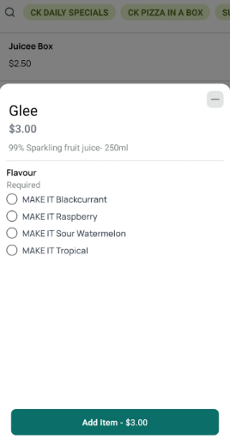



1. Once you have selected all items you can go to My Order and Checkout and Pay.

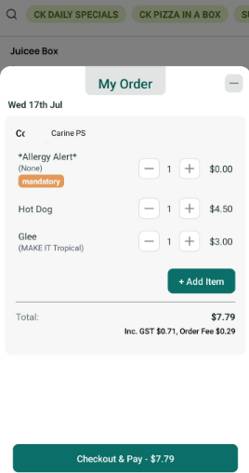



1. You may already have money in your FlexiSchool account/wallet to pay directly from or you can put in your credit card details for purchase.
2. You should also receive and email of your order details.
3. IF you want to check your order details in FlexiSchool app, then go into your Orders and you can see the history of all your previous orders.



1. You can check your current amount you have in your FlexiSchool account by going into the WALLET tab, or if you want to check your profile to update your children’s details or manage your details or change password you go into the PROFILE tab.



