HOW TO REGISTER FOR QUICKCLIQ
Register
- Click here to register.

Get started
- Click here to log in to QuickCliq
- Click “ADD STUDENT”. Ensure you complete all of your child’s details before clicking “NEXT”.
- Click “ADD CREDIT” to add credit to your account.
- Click “EVENTS tab” to add a special P&C order e.g Pizza Day, Donut Day
- Click the “UNIFORMS tab” menu to place a uniform order.

To Order through Events tab
- Click on Events tab

- Select the Event you want by clicking on “Place Order”.
- Tick the box of the item and the Quantity from the drop-down box – then click “CONFIRM”.
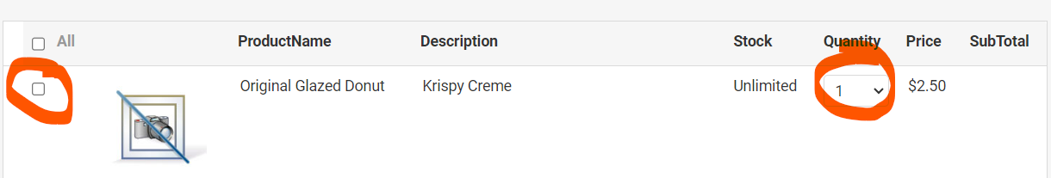
- Select the Shipping Details and remember to select the which child from the drop-down box.
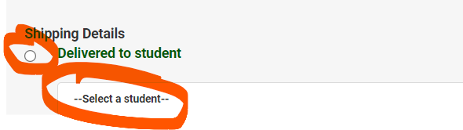
- Scroll down and enter in Parent Contact details and click on “PAY & PLACE ORDER”

Once you have confirmed and paid for the order, you will receive a confirmation email from QuickCliq. You can also double check your order by clicking either the “ACTIVE / CANCEL ORDERS” tab or the “TRANSACTION HISTORY” button.

Contact Details
If you have any concerns, or need help, please email QuickCliq at support@quickcliq.com.au or call 1300 11 66 37.
If you have any Monday or Wednesday meal related issues, please contact Carine
Senior High School Canteen. | Tel: 0413 827 883 OR Email: canteenkingswa@gmail.com

