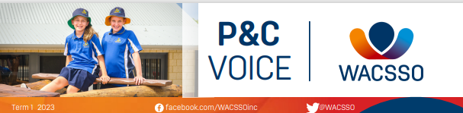

The Western Australian Council of State School Organisations Incorporated (WACSSO) was established in 1921 and is directed by affiliated Parents and Citizens' Associations.

http://www.wacsso.wa.edu.au/

Western Australian Council of State School Organisations Inc. (WACSSO)
We are the peak body representing parents of public school students in Western Australia. We provide services and representation at State and National level to more than 650 Parents and Citizens Associations (P&Cs) in Western Australia.
Together with the P&C community and all our stakeholders, WACSSO works tirelessly to advance public education in Western Australia, so that every student has the best chance to realise their potential and live the life they deserve.
WACSSO is largely a volunteer organisation made up of Councillors (representatives) from 20 electorates across Western Australia. State Councillors attend five weekend State Council meetings each year, where they debate and discuss issues relevant to parents and students in public schools. A State Conference is held once a year, usually in August, where both Councillors and representatives from P&C Associations congregate to discuss and decide on the direction of the organisation.
WACSSO also employs a small, dedicated team of staff to support Councillors and provide expert advice to affiliates.

